Jeroo Project

By Gabriel Aizenman

Lab Goal: This lab assignment will help you review the use of certain types of loops and methods needed for specific moments

Lab Description: For this lab assignment, you are to use methods and loops to make a Jeroo go around the island collecting all the flowers. You then have to replace the flowers in a mirror image of the original arrangement.

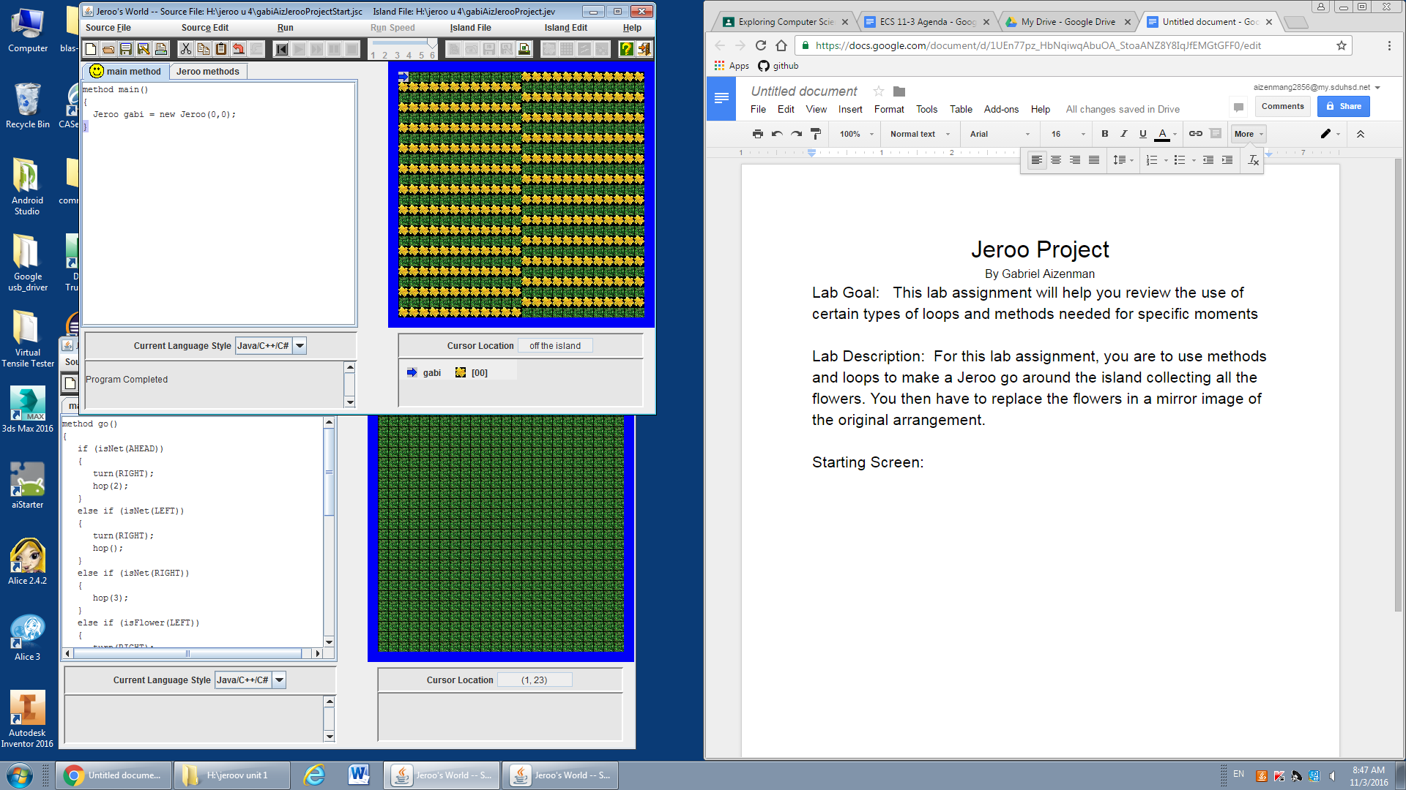

Starting Screen:

Files Needed:

gabiAizJerooProject.jsc

gabiAizJerooProject.jev

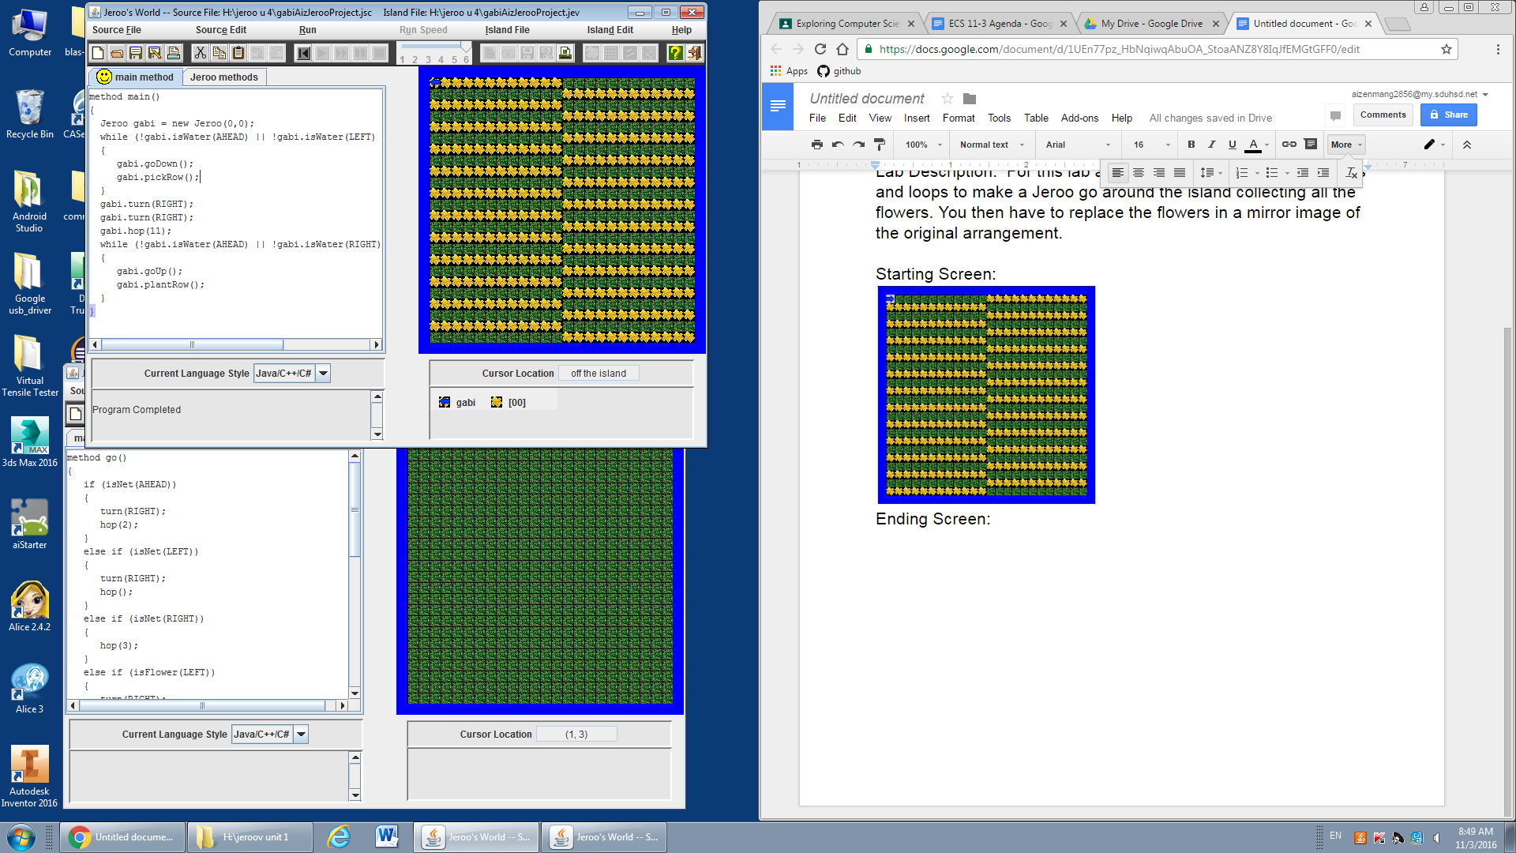

Ending Screen: